(SECJ1013) PROGRAMMING TECHNIQUE 1
SEM 1, SESSION 2023/2024
LAB EXERCISE 4 (4%)

INSTRUCTIONS TO THE STUDENTS
- This exercise must be done individually.
- Any form of plagiarism is NOT ALLOWED. Students who copied other students' assignments will get ZERO marks (both parties, students who copied, and students who shared their work).

SUBMISSION PROCEDURE
- Please submit this exercise no later than January 18, 2023, Thursday (11.59 PM MYT) through e-learning.

Scenario 1 (Chapter 6 Input and Output)
Search for a specified keyword, calculate the percentage of lines containing that keyword, and display the results in a clear and formatted manner. The modular design enhances code readability and maintainability. However, for real-world applications, you might want to consider additional error handling, testing, and potentially incorporating more advanced features based on the specific requirements of your data engineering tasks.

Given input the text paragraph and press Enter to signify the end of the input. The program will then calculate the percentage of lines containing the keyword "data" and display the results. Adjust the input text and keyword as needed for your testing or scenarios.

Input:
A data engineer is someone who builds and maintains the systems that data scientists and data analysts use to collect, store, and analyze data. They use their skills to design and build data pipelines, and to ensure that data is stored in a secure and efficient way. Data engineers are in high demand across a wide range of industries, including finance, healthcare, retail, and technology.

Task:
Create a C++ program (named as scenario1.cpp) allows the user to input text, search for a specified keyword, and then to calculate the percentage of lines (from the text paragraph using an array of characters) containing the keyword "data" and display the results.
Use the following steps:
- calculateKeywordPercentage function:
- This function calculates the percentage of lines in a given input containing a specified keyword.
- It uses a loop to iterate through the input and count lines containing the specified keyword using the strstr function.
- Main function:
- It declares a constant MAX_SIZE to define the maximum size of the input array and an array userInput to store the entered input.
- It prompts the user to enter the input until an empty line is encountered, using cin.getline.
- It calculates the actual length of the entered input using a loop.
- It specifies the keyword to search for (e.g., "data").
- It calls the calculateKeywordPercentage function to calculate the percentage of lines containing the specified keyword.
- It displays the entered input and the percentage of lines containing the keyword in a formatted manner.
- Include the necessary header files.

Sample Output Execution:
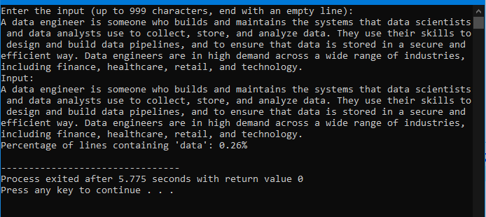

Scenario 2 (Chapter 6 Input and Output)
To modify the code from Scenario 1 (and rename the filename as scenario2.cpp) to read the DNA sequence from an input file and write the results to an output file.
Use the following steps:
- Include the necessary header for file handling.
- Input File Handling:
- Open an input file ("input2.txt").
- Read the DNA sequence from the input file using getLine.
- Close the input file.
- Output File Handling:
- Open an output file ("output2.txt").
- Display and write the results to the output file.
- Close the output file.
- User Interface Modification:
- Inform the user that the results have been written to the output file.

Sample Output Execution:
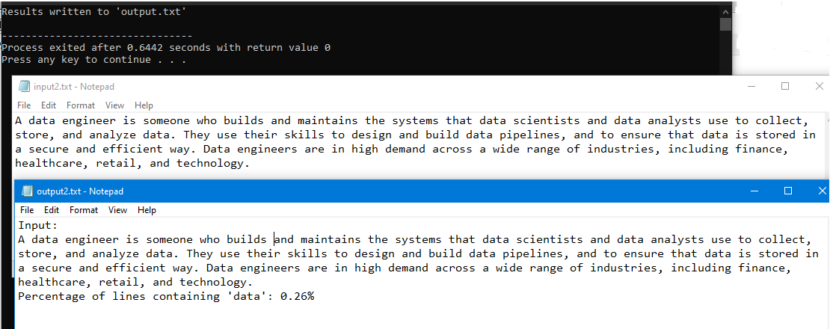

Scenario 3 (Chapter 7 Pointers)
To modify the code from Scenario 2 (and rename the filename as scenario3.cpp) to use pointers for the calculateKeywordPercentage function, instead of array indexing while maintaining the functionality of the original code.
Use the following steps:
- Changed the parameter const char input[] to const char* input in the calculateKeywordPercentage function to use a pointer.
- Updated the function call in main to pass userInput as a pointer.

Sample Output Execution:


